**Developments on Control Board and DSP software**

1. DC bus voltage measurement from each module
2. Phase current measurement from each module
3. Position and speed measurement from encoder
4. Motor speed control
5. Phase current control for each module
6. Balancing of DC bus voltages
7. Waveform synthesizing with PWM for low harmonic content
8. DC bus overvoltage protection
9. Phase overcurrent protection
10. Short circuit protection (?)
11. Advanced techniques (fault detection, operation under fault etc.)



Fig. 1. General control block diagram



Fig. 2. Speed and voltage controllers



Fig. 3. Current controller



Fig. 4. Control system timing

**PWM generation:**

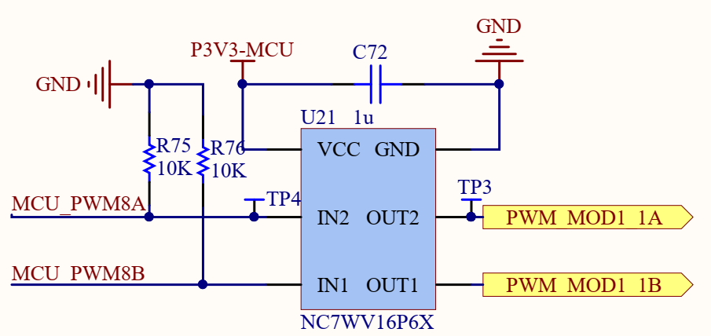

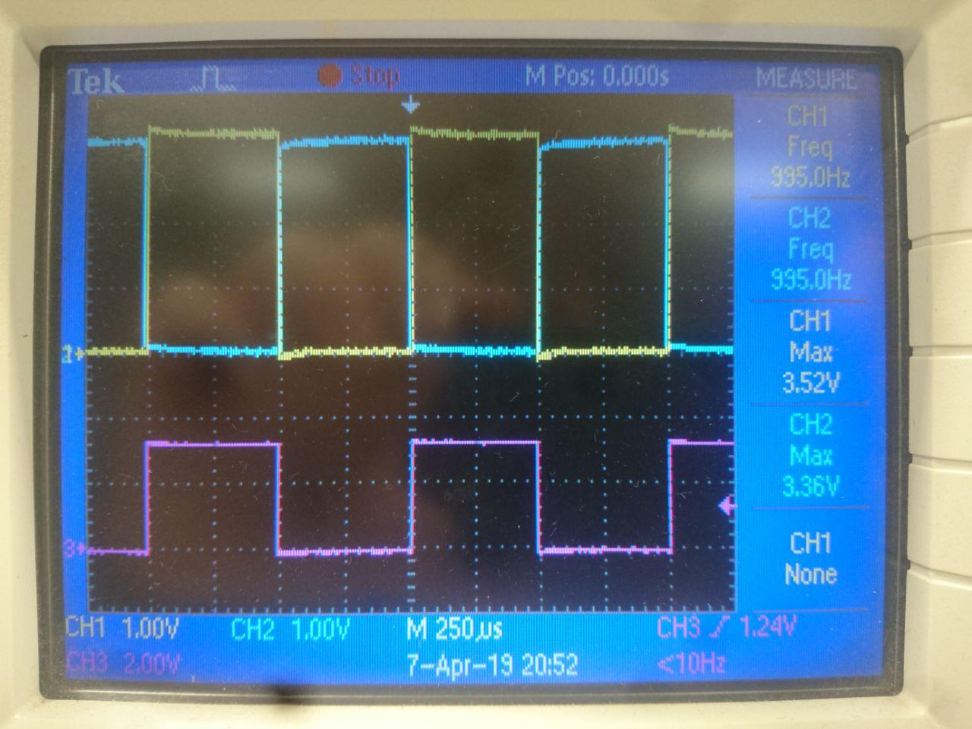

**Measurement with ADC:**

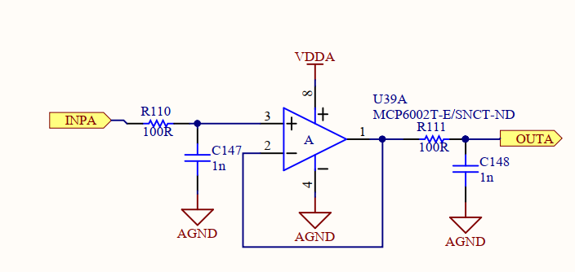 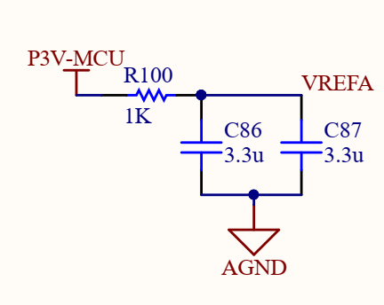 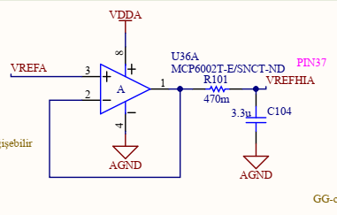

**Control system timing:**



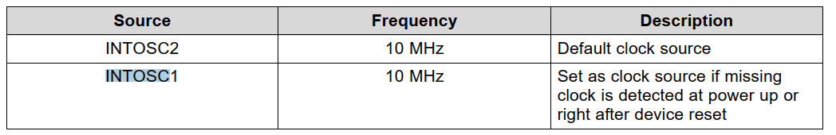



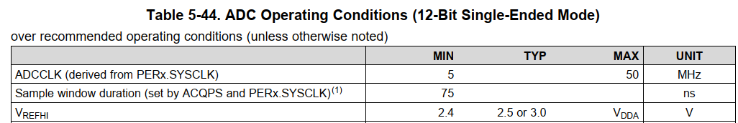

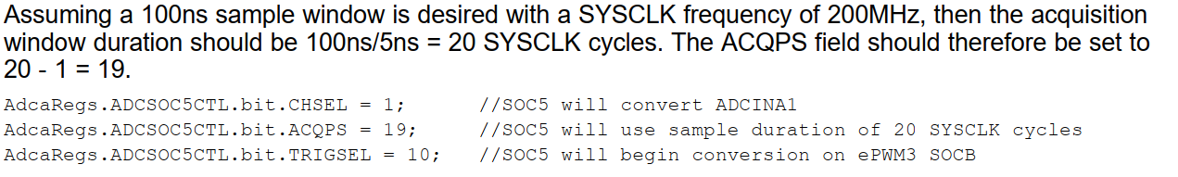

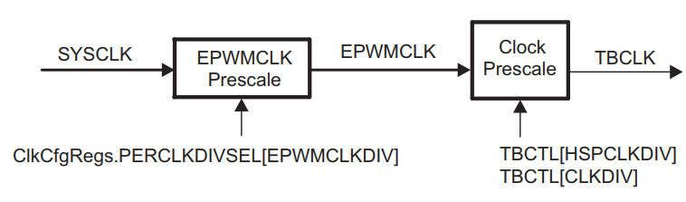

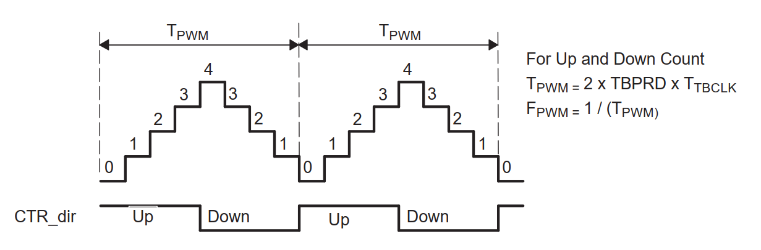

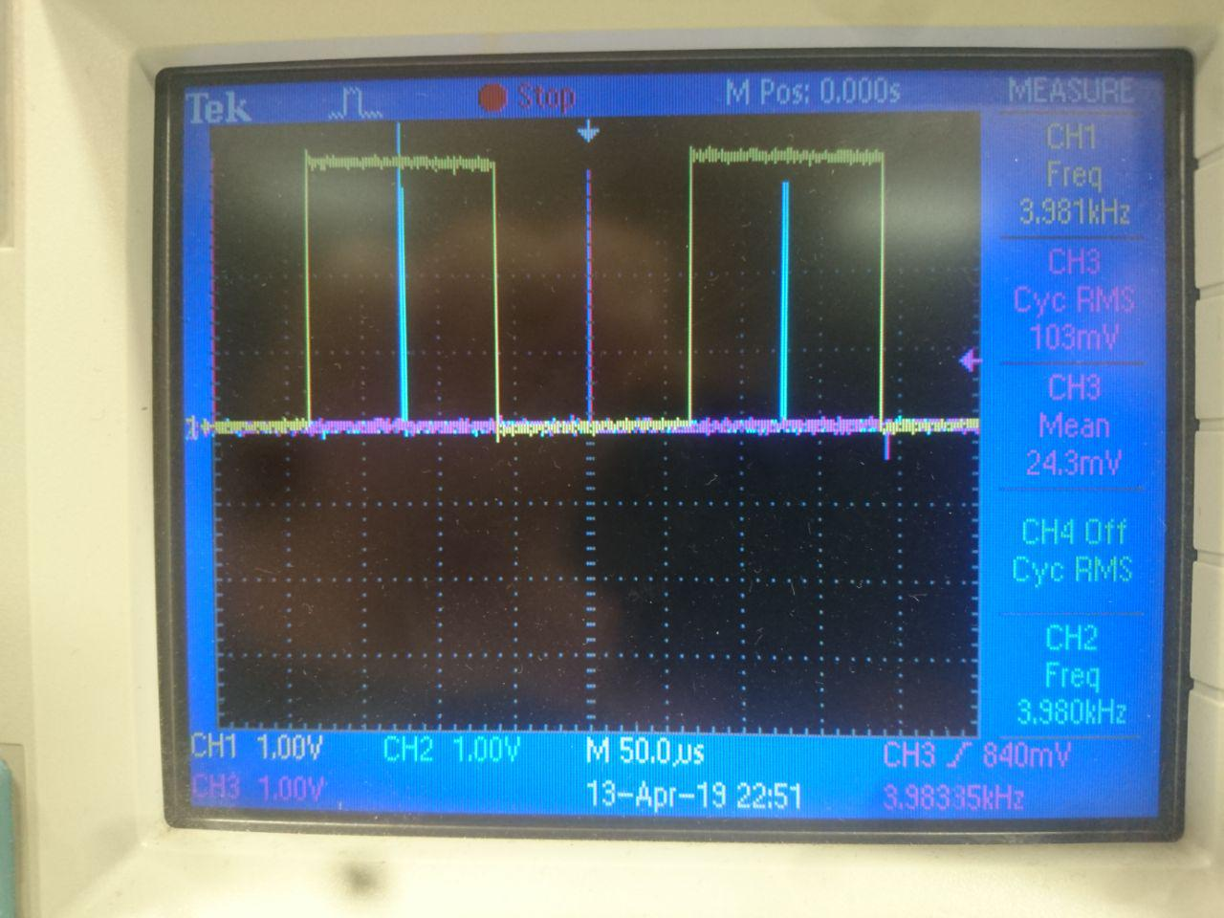

**ADC results**

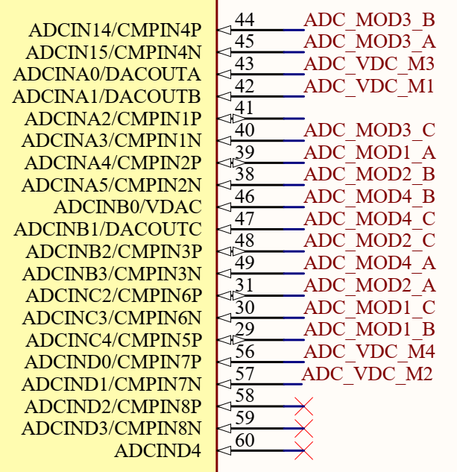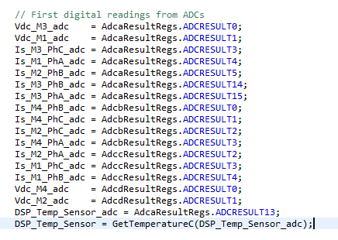

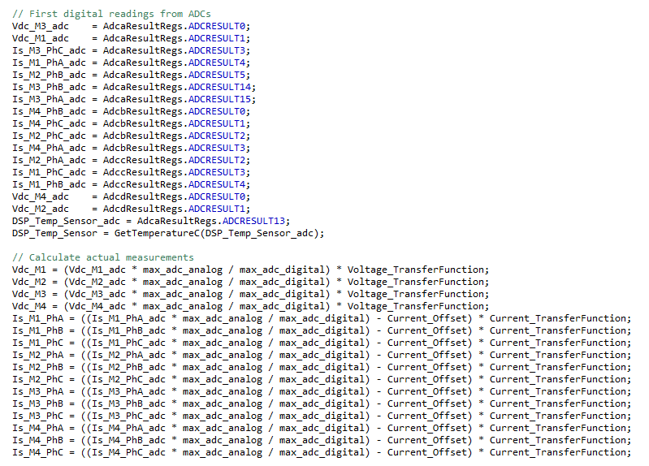

**PI controller:**

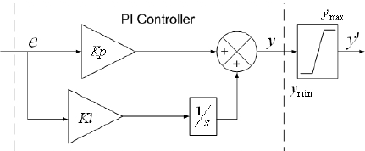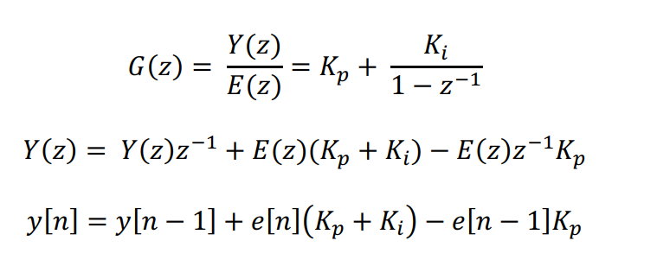

**Transformations:**

Clarke and Inverse Clark

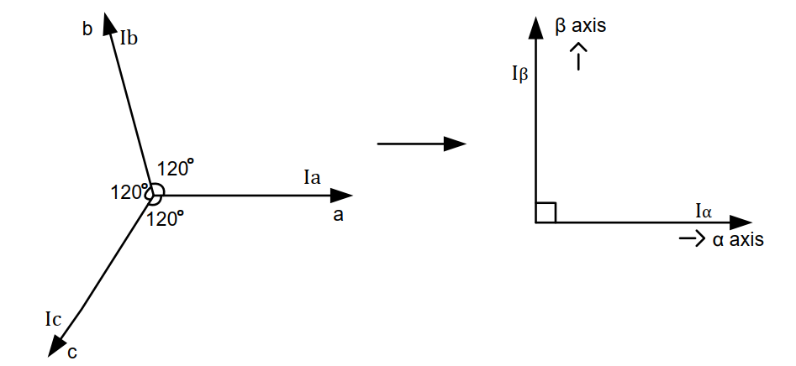 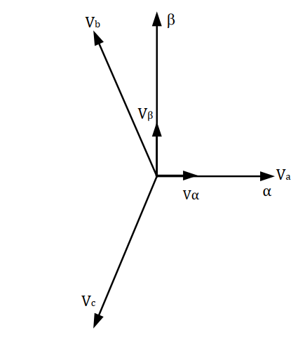





Park and Inverse Park

